CQ2Leak Status post Bariatric Surgery
Stem: A 45-year-old male presents to the emergency room with left chest and back pain, nausea, shortness of breath, and subjective fever. He underwent an uncomplicated laparoscopic bariatric procedure 10 days earlier in another hospital, and his current body mass index (BMI) is 58 m/kg2.
PE: Diaphoretic. Vitals: Temp 38.5°C, HR 114, Bl.Pr 114/75, RR 20, O2 94%. Abdomen is nontender and incision sites are dry and intact without signs of erythema or drainage.
PMH/PSH: GERD, HTN, Hyperlipidemia, COPD, appendectomy.
Social History: Prior smoker, drinks EtOH weekly.
Meds: Metformin.
Family history: Unremarkable.

Labs: CBC (WBC 18000, H&H 11/32) BMP (Na 144, k 4.5, Cl 98, Cr 2.9) Troponin Normal. Lactate 3.9.

What is your Differential Diagnosis?
- GI leak.
- Postoperative bleeding.
- Missed bowel injury.
- Missed pancreatic injury.
- PE. (Hence CT chest below)
- MI
What would you like to do now?
- Resuscitation: Two wide bore IV cannulas, IVF, Broad spectrum Abx.
- Obtain operative report.
- CT Chest, a bdomen and pelvis:What Contrast? IV &Oral. Oral should be specifically mentioned.
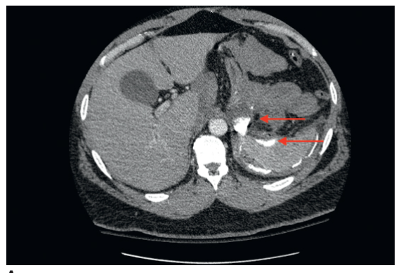

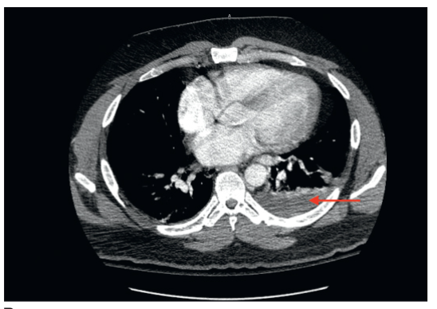
Contrast extravasation and extraluminal air along with a complex fluid collection located in the left subdiaphragmatic space.
You obtain and review the operative report, patient procedure was sleeve gastrectomy, what is your diagnosis in this case and how would you proceed.
- Gastric staple line leak, presenting with sepsis.
- Laparoscopic exploration. (Preferred) for irrigation and Drainage.
Endoscopic stent is not the best answer due to the presentation with sepsis requiring drainage/washout of infected fluid however the answer could include placement of a stent at the time of surgery versus suture repair of a leak depending on leak location (ie useful if proximal stomach) (DeMaria)
Describe how you would perform the procedure?
- Veress needle at Palmer’s point.
- Port is placed in the left upper quadrant. Angled laparoscope (5 or 10 mm)
- T he patient is placed in the steep reverse Trendelenburg position, and additional ports are placed.
- Left lateral segment of the liver is retracted to facilitate exploration.
- Careful exploration of the left upper quadrant with blunt atraumatic graspers.
- Intraoperative endoscopy can facilitate identification of the location of the leak using air insufflation technique.
- I dentify and drain any abscess cavit y.
- I rrigate copiously with warm saline.
- P lace one or more drains into the abscess cavity in anticipation of as a continued leak post op is very likely in the setting of sleeve leak..

If appropriate drainage/washout cannot be accomplished via laparoscopy then open conversion is appropriate in order to accomplish.
(Examiner please note, Identification of the exact location of the leak is not absolutely necessary, the primary focus of this exploration is drainage. In addition, primary repair is often not feasible, and narrowing by overzealous attempts at repair of a sleeve or gastric bypass pouch leak can result in a stricture. )
- You identify the leak site, now what? Omental patch, placing seromuscular sutures through healthy gastric tissue and omentum.

- Endoscopic stent placement can be considered if leak location is identifiable and immediately available expertise to perform this procedure including fluoro, stents,etc.
Might need to be delayed until appropriate personnel available and further imaging determine precise leak location. Mi

- Consider placing feeding jejunostomy. Describe?
  - P lac e four sutures (2-0 braided absorbable sutures are used typically) in a diamond formation along the antimesenteric portion of the small bowel.
  - E nterotomy is created in the middle of the four sutures.
  - 12- to 14-Fr silastic feeding tube is advanced into the bowel directing it distally along the jejunum.
  - The four sutures are anchored to the abdominal wall
  - The drain is then sutured to the skin with a 3-0 nylon suture.
What are some potential complications that can occur during or following this takeback surgery?
- Splenic injury
- Pancreatic injury.
- Splenic flexure colon injury.
- Gastrocolic fistulas
- Chronic fistula from leak site.

